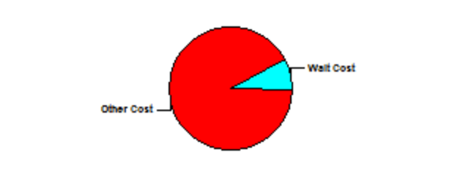
Category Overview
14:16:25
Mai 24, 2013
HardRock
Time Units:
Replications:
100
Hours
Values Across All Replications
Key Performance Indicators
Average
All Entities
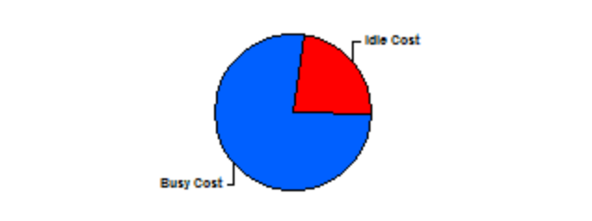
Non-Value Added Cost
0
Other Cost
6,261
Transfer Cost
0
Value Added Cost
0
Wait Cost
569
Total Cost
6,830
Average
All Resources
Busy Cost
*
6,830
Idle Cost
2,060
Usage Cost
0
Total Cost
8,890
* these costs are included in Entity Costs above.
Average
System
Total Cost
8,890
Number Out
767
Model Filename:
Page
of
1
8
Z:\Temp\BA\Models\Arena\GitHub\Model12

Category Overview
14:16:25
Mai 24, 2013
HardRock
Time Units:
Replications:
100
Hours
Values Across All Replications
Entity
Time
VA Time
Maximum
Average
Minimum
Average
Half Width
Average
Minimum
Value
Maximum
Value
0.04924605
Client
0.00
0.04714677
0.05115268
0.00
0.08333329
NVA Time
Maximum
Average
Minimum
Average
Half Width
Average
Minimum
Value
Maximum
Value
0.00
Client
0.00
0.00
0.00
0.00
0.00
Wait Time
Maximum
Average
Minimum
Average
Half Width
Average
Minimum
Value
Maximum
Value
1.2597
Client
0.01
1.1240
1.3606
0.00
2.8863
Transfer Time
Maximum
Average
Minimum
Average
Half Width
Average
Minimum
Value
Maximum
Value
0.00
Client
0.00
0.00
0.00
0.00
0.00
Other Time
Maximum
Average
Minimum
Average
Half Width
Average
Minimum
Value
Maximum
Value
0.3745
Client
0.00
0.3581
0.3903
0.00
0.8939
Total Time
Maximum
Average
Minimum
Average
Half Width
Average
Minimum
Value
Maximum
Value
1.3708
Client
0.01
1.2436
1.4726
0.00
2.4747
Cost
VA Cost
Maximum
Average
Minimum
Average
Half Width
Average
Minimum
Value
Maximum
Value
0.00
Client
0.00
0.00
0.00
0.00
0.00
NVA Cost
Maximum
Average
Minimum
Average
Half Width
Average
Minimum
Value
Maximum
Value
0.00
Client
0.00
0.00
0.00
0.00
0.00
Wait Cost
Maximum
Average
Minimum
Average
Half Width
Average
Minimum
Value
Maximum
Value
0.7388
Client
0.00
0.7022
0.7744
0.00
1.3333
Other Cost
Maximum
Average
Minimum
Average
Half Width
Average
Minimum
Value
Maximum
Value
8.1283
Client
0.03
7.7666
8.5262
0.00
21.0833
Transfer Cost
Maximum
Average
Minimum
Average
Half Width
Average
Minimum
Value
Maximum
Value
0.00
Client
0.00
0.00
0.00
0.00
0.00
Model Filename:
Page
of
2
8
Z:\Temp\BA\Models\Arena\GitHub\Model12

Category Overview
14:16:25
Mai 24, 2013
HardRock
Time Units:
Replications:
100
Hours
Values Across All Replications
Entity
Cost
Total Cost
Maximum
Average
Minimum
Average
Half Width
Average
Minimum
Value
Maximum
Value
8.8671
Client
0.03
8.4829
9.2663
0.00
22.2700
Other
Number In
Maximum
Average
Minimum
Average
Half Width
Average
Client
20.80
3299.05
3526.00
3047.00
Number Out
Maximum
Average
Minimum
Average
Half Width
Average
Client
20.23
3285.12
3509.00
3030.00
WIP
Maximum
Average
Minimum
Average
Half Width
Average
Minimum
Value
Maximum
Value
225.87
Client
1.88
203.45
245.45
0.00
362.00
Model Filename:
Page
of
3
8
Z:\Temp\BA\Models\Arena\GitHub\Model12

Category Overview
14:16:25
Mai 24, 2013
HardRock
Time Units:
Replications:
100
Hours
Values Across All Replications
Queue
Time
Waiting Time
Maximum
Average
Minimum
Average
Half Width
Average
Minimum
Value
Maximum
Value
0.06361087
CookBatch.Queue
0.00
0.05963287
0.06954629
0.00
0.3872
0.00818974
Seize Bar.Queue
0.00
0.00
0.02193006
0.00
0.3476
0.01766144
Seize Cook.Queue
0.00
0.00785642
0.03994014
0.00
0.1860
0.01080312
Seize Dish Service.Queue
0.00
0.00734090
0.01454572
0.00
0.1548
0.2839
Seize Service.Queue
0.01
0.1906
0.3702
0.00
0.7749
0.04511126
Seize Table.Queue
0.00
0.00020227
0.08380691
0.00
0.4443
Cost
Waiting Cost
Maximum
Average
Minimum
Average
Half Width
Average
Minimum
Value
Maximum
Value
0.00
CookBatch.Queue
0.00
0.00
0.00
0.00
0.00
0.00
Seize Bar.Queue
0.00
0.00
0.00
0.00
0.00
0.00
Seize Cook.Queue
0.00
0.00
0.00
0.00
0.00
0.00
Seize Dish Service.Queue
0.00
0.00
0.00
0.00
0.00
0.00
Seize Service.Queue
0.00
0.00
0.00
0.00
0.00
0.00
Seize Table.Queue
0.00
0.00
0.00
0.00
0.00
Other
Number Waiting
Maximum
Average
Minimum
Average
Half Width
Average
Minimum
Value
Maximum
Value
11.4937
CookBatch.Queue
0.12
10.0962
13.0374
0.00
32.0000
0.00
Enter Cafe.Queue
0.00
0.00
0.00
0.00
0.00
0.4481
Seize Bar.Queue
0.07
0.00
1.2281
0.00
10.0000
2.2388
Seize Cook.Queue
0.16
0.9562
4.9126
0.00
31.0000
0.5858
Seize Dish Service.Queue
0.02
0.3990
0.7979
0.00
11.0000
15.4264
Seize Service.Queue
0.47
9.8045
20.8618
0.00
52.0000
2.4645
Seize Table.Queue
0.23
0.01040224
4.6932
0.00
21.0000
Model Filename:
Page
of
4
8
Z:\Temp\BA\Models\Arena\GitHub\Model12

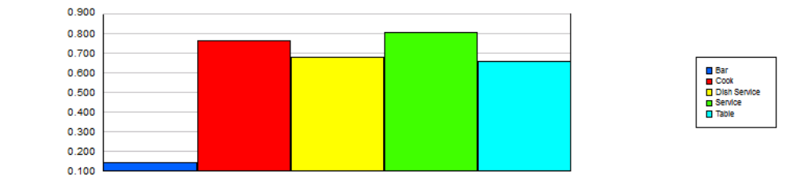
Category Overview
14:16:25
Mai 24, 2013
HardRock
Time Units:
Replications:
100
Hours
Values Across All Replications
Resource
Usage
Instantaneous Utilization
Maximum
Average
Minimum
Average
Half Width
Average
Minimum
Value
Maximum
Value
0.1446
Bar
0.01
0.00052092
0.2839
0.00
1.0000
0.7613
Cook
0.01
0.6862
0.8161
0.00
1.0000
0.6772
Dish Service
0.00
0.6169
0.7245
0.00
1.0000
0.8033
Service
0.00
0.7420
0.8591
0.00
1.0000
0.6550
Table
0.01
0.5715
0.7250
0.00
1.0000
Number Busy
Maximum
Average
Minimum
Average
Half Width
Average
Minimum
Value
Maximum
Value
5.7848
Bar
0.53
0.02083689
11.3560
0.00
40.0000
10.6587
Cook
0.07
9.6070
11.4254
0.00
14.0000
2.0317
Dish Service
0.01
1.8506
2.1736
0.00
3.0000
7.2293
Service
0.04
6.6776
7.7316
0.00
9.0000
163.75
Table
1.76
142.88
181.26
0.00
250.00
Number Scheduled
Maximum
Average
Minimum
Average
Half Width
Average
Minimum
Value
Maximum
Value
40.0000
Bar
0.00
40.0000
40.0000
40.0000
40.0000
14.0000
Cook
0.00
14.0000
14.0000
14.0000
14.0000
3.0000
Dish Service
0.00
3.0000
3.0000
3.0000
3.0000
9.0000
Service
0.00
9.0000
9.0000
9.0000
9.0000
250.00
Table
0.00
250.00
250.00
250.00
250.00
Scheduled Utilization
Maximum
Average
Minimum
Average
Half Width
Average
Bar
0.01
0.1446
0.2839
0.00052092
Cook
0.01
0.7613
0.8161
0.6862
Dish Service
0.00
0.6772
0.7245
0.6169
Service
0.00
0.8033
0.8591
0.7420
Table
0.01
0.6550
0.7250
0.5715
Model Filename:
Page
of
5
8
Z:\Temp\BA\Models\Arena\GitHub\Model12

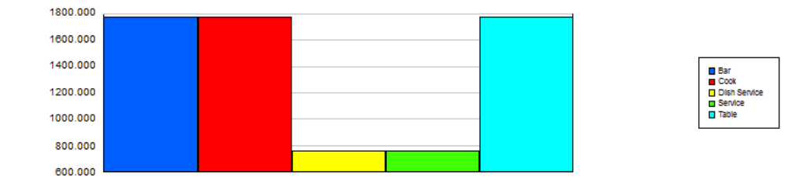
Category Overview
14:16:25
Mai 24, 2013
HardRock
Time Units:
Replications:
100
Hours
Values Across All Replications
Resource
Usage
Total Number Seized
Maximum
Average
Minimum
Average
Half Width
Average
Bar
11.16
1770.17
1861.00
1635.00
Cook
11.16
1770.17
1861.00
1635.00
Dish Service
4.53
758.74
816.00
700.00
Service
4.53
758.74
816.00
700.00
Table
11.16
1770.17
1861.00
1635.00
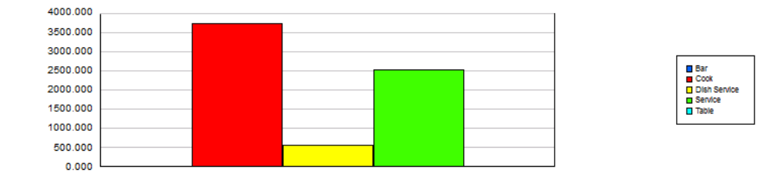
Cost
Busy Cost
Maximum
Average
Minimum
Average
Half Width
Average
Bar
0.00
0.00
0.00
0.00
Cook
25.52
3730.54
3998.87
3362.45
Dish Service
3.50
568.87
608.61
518.18
Service
15.34
2530.27
2706.05
2337.17
Table
0.00
0.00
0.00
0.00
Model Filename:
Page
of
6
8
Z:\Temp\BA\Models\Arena\GitHub\Model12

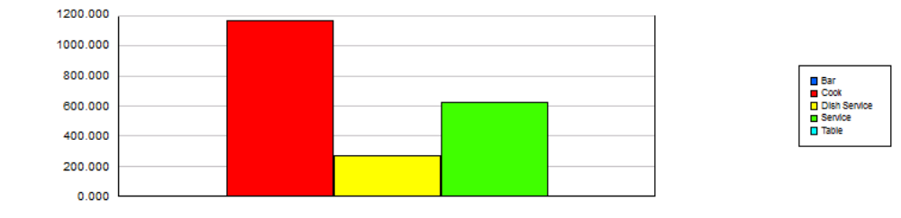
Category Overview
14:16:25
Mai 24, 2013
HardRock
Time Units:
Replications:
100
Hours
Values Across All Replications
Resource
Cost
Idle Cost
Maximum
Average
Minimum
Average
Half Width
Average
Bar
0.00
0.00
0.00
0.00
Cook
25.52
1169.46
1537.55
901.13
Dish Service
3.50
271.13
321.82
231.39
Service
15.34
619.73
812.83
443.95
Table
0.00
0.00
0.00
0.00
Usage Cost
Maximum
Average
Minimum
Average
Half Width
Average
Bar
0.00
0.00
0.00
0.00
Cook
0.00
0.00
0.00
0.00
Dish Service
0.00
0.00
0.00
0.00
Service
0.00
0.00
0.00
0.00
Table
0.00
0.00
0.00
0.00
Model Filename:
Page
of
7
8
Z:\Temp\BA\Models\Arena\GitHub\Model12

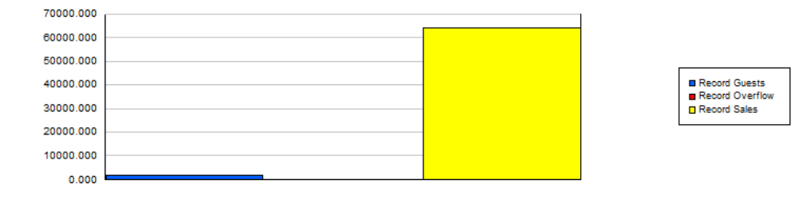
Category Overview
14:16:25
Mai 24, 2013
HardRock
Time Units:
Replications:
100
Hours
Values Across All Replications
User Specified
Tally
Interval
Maximum
Average
Minimum
Average
Half Width
Average
Minimum
Value
Maximum
Value
0.1035
Record At Table
0.01
0.05106868
0.1563
0.01667029
0.6205
0.6393
Record eating time
0.00
0.6270
0.6510
0.2508
0.9973
0.1334
Record Ordering
0.00
0.1315
0.1353
0.06749797
0.1992
1.3914
Record Total
0.01
1.2436
1.5073
0.5349
2.4747
0.1808
Record Wait For Dish
0.00
0.1674
0.1985
0.00893856
0.4561
Counter
Count
Maximum
Average
Minimum
Average
Half Width
Average
1762.46
Record Guests
10.89
1851.00
1626.00
26.8000
Record Overflow
5.74
97.0000
0.00
64171.42
Record Sales
409.80
68040.00
59433.00
Model Filename:
Page
of
8
8
Z:\Temp\BA\Models\Arena\GitHub\Model12

